# Department: DPAM

# Course: BS PHYSICS

# Name: Umar Shifaqat

# Serial No. 43

**QUESTION NO. 1 :**

**INPUT:**

#include<stdio.h>

int main()

{

int n,integer,i,prime,total=0;

for (n=1;n<=20;n++)

{

printf("\nEnter an integer : ");

scanf("%d",&integer);

prime=1;

for(i=2;i<integer;i++)

{

if (integer%i==0)

{ prime=0;

break; }

else

//prime=1

;

}

if(prime==1)

{ printf("\t\t\t\tPrime ");

total++;

}

}

printf("\n\n\t\tThe No. of Prime Numbers entered are %d ",total);

getchar();

getchar();

getchar();

return 0;

}

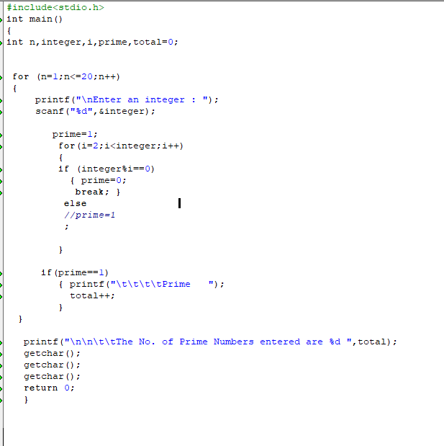

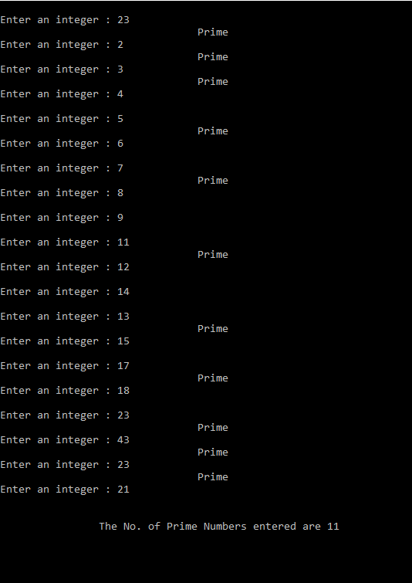

**QUESTION NO. 2:**

**INPUT CODE:**

#include<stdio.h>

int main()

{

int num,n=1,x,y,z;

float net=0,value;

do{

printf("\nEnter a number from 1 to 10: ");

scanf("%d",&num);

if(num<1||num>10)

printf("Invalid Number entered\n");

else

break;

} while (1);

while(n<=num)

{

x=n+1;

y=10*x;

z=5*n;

printf("\(%d - %d \)/%d ",y,5*x,z);

value=(float)(y-5*x)/z;

if(n%2==0)

value=-value;

net+=value;

if(num==n)

break;

if(n%2==1)

printf("-");

else

printf("+");

n++;

}

printf("\n\tNet answer : %f",net);

getchar();

getchar();

getchar();

return 0;

}

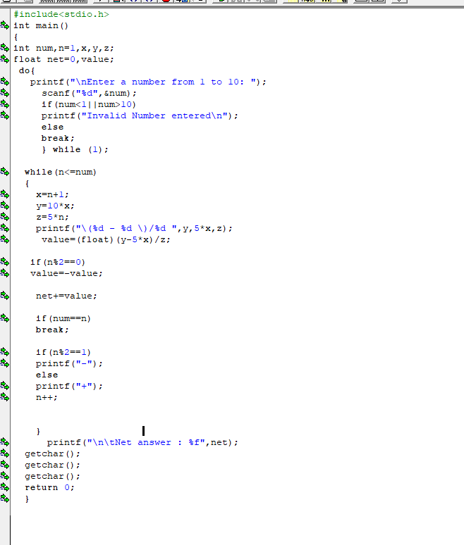

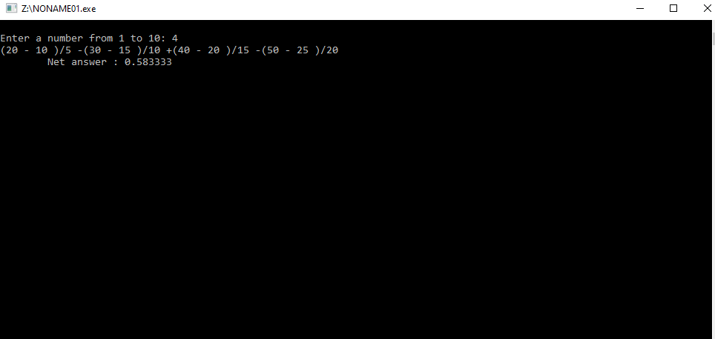

**QUESTION NO. 3:**

**INPUT:**

#include<stdio.h>

int main ()

{

int A=4,Ai,n;

printf("Enter a number from 1 to 12\n\n \t\tn = ");

scanf("%d",&n);

int num=1;

while(num<=n)

{

if (n<1|| n>12)

{ printf("\n\tYou have enterd wrong number");

break;

}

Ai=5*(A-1)+3;

printf("\n \tA%d = %d",A+1,Ai);

A++;

num++;

}

getchar();

getchar();

getchar();

return 0;

}

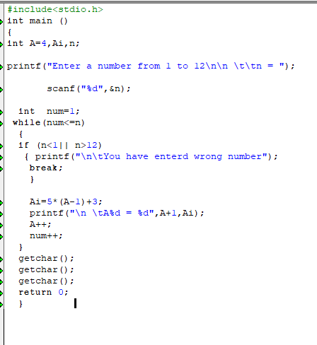

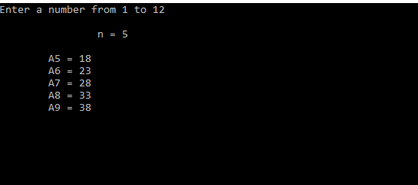

**THE END**